In project Development Life cycle, The following activities are done.

1. Analysis.
2. Design
3. Coding
4. Testing
5. Deployment.

The above activities are usually done in specified order. This is normal engineering.

Where as

If we do first coding,testing and preparing documents, this is called reverse engineering.

**Any thing opposite of regular activity is called reverse engineering.**

**Hibernate Reverse Engineering:-**

Normally, we do following activities manually while developing the normal hibernate application.

* Keeping tables in DB
* Creating the domain class
* Mapping domain class and its properties with relation and its columns.

While developing the normal hibernate application.

Where as, the **reverse eng tool** will generate domain class,mapping file(if needded), configuration file dynamically and automatically based on given table. Therefore the programmer does not need to create domain class, mapping file and configuration file in hibernate application.

**Steps to Install hibernate reverse engineering tool in eclipse IDE.**

**Step1:**Help-> install software

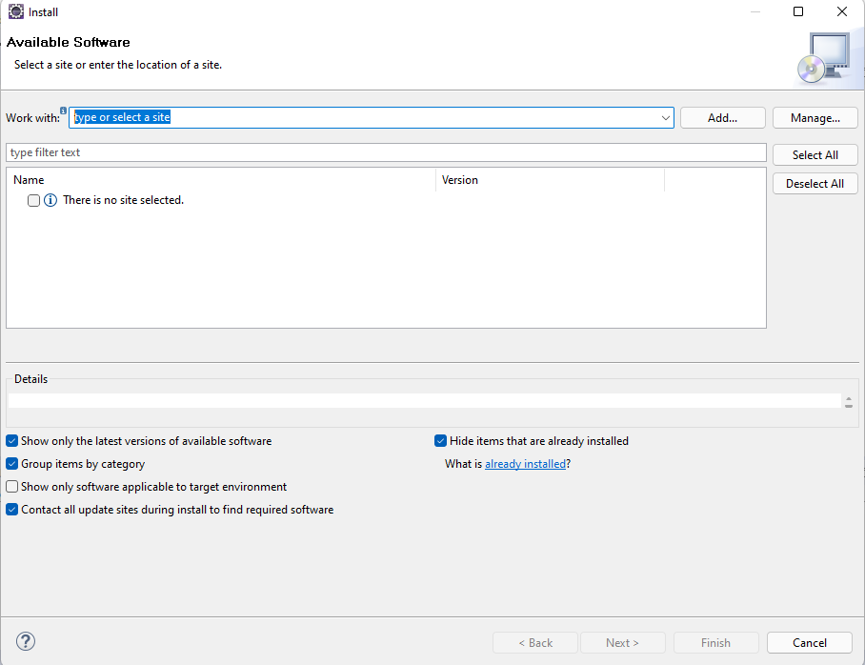

**Step2:** enter following url in “work with” text box.

<http://download.jboss.org/jbosstools/neon/stable/updates/>

**step3:**

Click on JBoss Application Development checkbox. Then we will see the list of choice.

Select the Hibernate Tools check box.

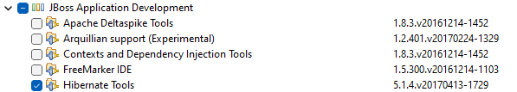

Click on “next” button.

**Step4:**

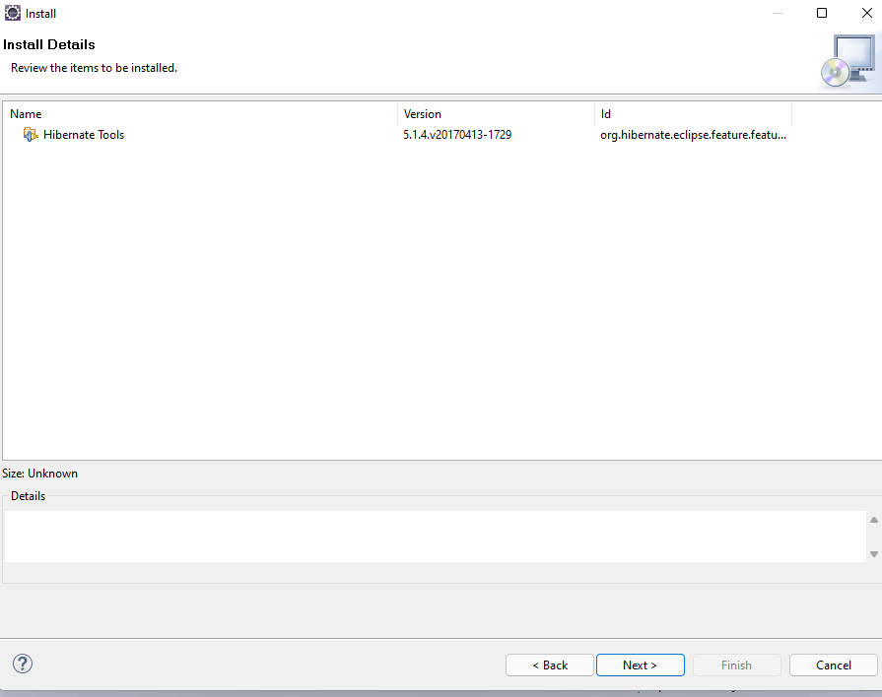

Select “hibernate tools” and press next.

**Step5:**

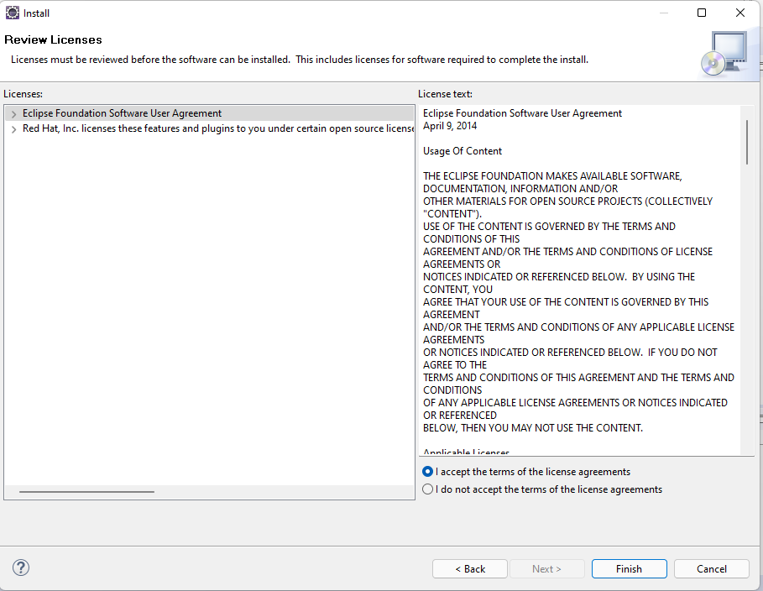

Select “ I accept the terms of the license agreements” radio button. And press the finish button.

**Steps to confirm whether plug-in installed or not**

window->perspective->open perspectives -> other

